CS3714 iOS Mobile Software Development

* Semester Project Report

Spring 2018

**ParKing**

Andrew J. Shivers, [sandrew2@vt.edu](mailto:sandrew2@vt.edu)

Tyler G. Urban, [turban@vt.edu](mailto:turban@vt.edu)

Kavin Aravind, [aravindk@vt.edu](mailto:aravindk@vt.edu)

Department of Computer Science

Virginia Tech

Blacksburg, VA 24061

*Date:* February 23, 2018

*Team Number:* 10

*Instructor:* Prof. Osman Balci

**EXECUTIVE SUMMARY**

Our app, ParKing, will be able to help millions of Americans save time and money on a daily basis. ParKing is an iOS app that will aid drivers in finding parking spots quickly and efficiently in prime cities in the U.S. According to a recent statistic from INRIX (a transportation analytics company) drivers spend an average of 17 hours a year searching for parking spots and up to $2243 in wasted time, fuel, and emissions per driver. In New York City, this costed the city $4.3 billion in wasted costs. That is YOUR time and money being wasted on a daily basis. We will also be incorporating crime data to allow drivers to make an informed decision on where to place their vehicle. Included in this document you will find all relevant information information about the design and implementation of our app. We have included a detailed explanation of our goals, problem and solution statements, all implemented features, requirement, architecture, and design specifications, software functionality as well as step-by-step instructions on how to implement new features.

**List of Implemented iOS Features Learned** (At least 3 required per team member)

1. Create an image slideshow
2. Read and process a Food Barcode, Product Barcode, and Quick Response (QR) code
3. Obtain JSON data from an API and properly process it
4. Remove keyboard by touching anywhere on the view's background
5. Scroll up the entire UI content to show a Text Field hidden under the keyboard
6. Determine and show user's current Location
7. Get Driving or Walking directions from one coordinate (latitude, longitude) to another and show it on map with a polyline
8. Show Standard, Satellite, or Hybrid map
9. Fit long titles in multiple lines within the Navigation Bar
10. Create and change buttons on the Navigation Bar programmatically at runtime
11. Using the Unwind design pattern
12. UIPickerView
13. Tab Bar-based Navigation
14. Custom-built table view rows (cells)
15. Color alternate table view rows for clarity of display
16. Ask for user's permission to access the iOS device's camera
17. Ask for user's permission to track geo-location
18. Show a web page using Apple's WKWebView

**List of Implemented New iOS Features (**At least 1 required per team member)

1. Augmented Reality ([ARKit](https://developer.apple.com/library/content/navigation/" \l "section=Technologies&topic=ARKit)) with [SceneKit](https://developer.apple.com/library/content/navigation/" \l "section=Technologies&topic=SceneKit)
2. JSON data processing from an API is considered as a new feature if the functionality it provides is new and significant. – Firebase
3. Enable user to send an email message within your app. The Mail app can be opened within your app in a view. The Mail app must be set up on the iOS device for this functionality to work
4. Authenticate user via [TouchID](https://support.apple.com/en-us/HT204587) or [FaceID](https://support.apple.com/en-us/HT208108) by using the [LocalAuthentication.framework](https://developer.apple.com/documentation/localauthentication)

**TABLE OF CONTENTS**

1. SOFTWARE LIFE CYCLE 1

1. OUR OBJECTIVE 2

2. PROBLEM SPECIFICATION 2

2.1 What is the problem? 2

2.2 Why is the problem important to solve by engineering an iOS application? 2

2.3 Learned and new iOS features to be implemented 3

3. REQUIREMENTS SPECIFICATION 4

3.1 Functional Requirements 4

3.2 Non-Functional Requirements 4

4. ARCHITECTURE SPECIFICATION 5

5. DESIGN SPECIFICATION 6

6. DELIVERED SOFTWARE FUNCTIONALITY 8

7. STEP-BY-STEP INSTRUCTIONS FOR DEVELOPING NEW FEATURES 18

7.2 Touch ID Authentication Using LocalAuthentication Framework 32

7.3 Send Email Message In The App 36

7.4 Store and Retrieve Data and Photos using Firebase Database and Storage 40

8. CONCLUSIONS 43

9. SUBMISSION INSTRUCTIONS 44

10. PERCENTAGES OF CONTRIBUTION 44

11. CALCULATION OF GRADES BASED ON PERCENTAGES OF CONTRIBUTION 45

12. TEAM PROJECT REQUIREMENTS 45

13. GRADING SHEET 46

# SOFTWARE LIFE CYCLE

A good software engineer develops software by following the software life cycle shown below.



A programmer (hacker or ad-hoc developer) develops software by looking at the problem and directly coding in an IDE. This approach is known as the *Build-and-Fix Approach*, which must never be used!

# OUR OBJECTIVE

The objective of our iOS team project is to **demonstrate how capable the team members are** in engineering an iOS app to solve a problem. The app is created for the purpose of showing how *learned* and *new* complex functionalities and iOS features the team members are capable of developing. The objective is **not** to develop an app for publishing it at the App store.

# PROBLEM SPECIFICATION

## What is the problem?

According to a recent statistic from INRIX (a transportation analytics company) drivers spend an average of 17 hours a year searching for parking spots and up to $2243 in wasted time, fuel, and emissions per driver. In New York City, this costed the city $4.3 billion in wasted costs. We would like to solve this issue, we are problem solvers after all. Our goal is to create an iOS app that will aid drivers in finding parking spots quickly and efficiently in prime cities in the U.S. We will also be incorporating crime data to allow drivers to make an informed decision on where to place their vehicle. We will also add transactional processing to speed up the payment process.

## Why is the problem important to solve by engineering an iOS application?

Over 64% of Americans own iOS devices based on the CNBC All-America Economic survey conducted in 2017. Of the top 5 highest cost cities (New York, Los Angeles, San Francisco, Washington D.C., and Seattle), all of them have overwhelming Apple IPhone adoption over Android devices according to an article by Time in 2014. Among the younger crowd the percentage of IPhone users is even higher with 78% owning an IPhone and 82% of those who don’t expecting to own one within the next year. (Piper Jaffray Semiannual Teen Survey) Therefore, the percentage of IPhone users among drivers should rise even higher as those users become eligible to drive. Combined the time wasted searching for parking spots costs these top five cities almost 10 billion dollars per year. We will be focusing on these five cities that are suffering the greatest costs due to parking, and later expanding to the next five cities (Chicago, Boston, Atlanta, Dallas, and Detroit).

## Learned and new iOS features to be implemented

Our proposed app shall implement the following *learned* and *new* iOS features.

**Table 1. List of Learned iOS Features to be Implemented**

|  |  |
| --- | --- |
| *No.* | *Description of the Learned iOS Feature to be Implemented* |
| 1 | Create an image slide show |
| 2 | Read and process a Food Barcode, Product Barcode, and Quick Response (QR) code |
| 3 | Obtain JSON data from an API and properly process it |
| 4 | Remove keyboard by touching anywhere on the view's background |
| 5 | Scroll up the entire UI content to show a Text Field hidden under the keyboard |
| 6 | Determine and show user's current Location |
| 7 | Get Driving or Walking directions from one coordinate (latitude, longitude) to another and show it on map with a polyline |
| 8 | Show Standard, Satellite, or Hybrid map |
| 9 | Create and change buttons on the Navigation Bar programmatically at runtime |
| 10 | Fit long titles in multiple lines within the Navigation Bar |
| 11 | Using the Unwind design pattern |
| 12 | UIPickerView |
| 13 | Tab Bar-based Navigation |
| 14 | Custom-built table view rows (cells) |
| 15 | Color alternate table view rows for clarity of display |
| 16 | Ask for user's permission to access the iOS device's camera |
| 17 | Ask for user's permission to track geo-location |
| 18 | Show a web page using Apple's WKWebView |

**Table 2. List of New iOS Features to be Implemented**

|  |  |
| --- | --- |
| *No.* | *Description of the New iOS Feature to be Implemented* |
| 1 | Augmented Reality ([ARKit](https://developer.apple.com/library/content/navigation/" \l "section=Technologies&topic=ARKit)) with [SceneKit](https://developer.apple.com/library/content/navigation/" \l "section=Technologies&topic=SceneKit) |
| 2 | Authenticate user via [TouchID](https://support.apple.com/en-us/HT204587) or [FaceID](https://support.apple.com/en-us/HT208108) by using the [LocalAuthentication.framework](https://developer.apple.com/documentation/localauthentication) |
| 3 | JSON data processing from an API is considered as a new feature if the functionality it provides is new and significant. – Firebase |
| 4 | Enable user to send an email message within your app. The Mail app can be opened within your app in a view. The Mail app must be set up on the iOS device for this functionality to work. |

# REQUIREMENTS SPECIFICATION

This section specifies the Functional and Non-Functional Requirements under which the iOS software application will be developed.

## Functional Requirements

1. The user shall authenticate themselves with TouchID authentication using the LocalAuthentication Framework. They shall not be allowed into the app without authentication using TouchID.
2. The user shall see no more than 50 of the closest spots from his or her location in the Closest Spots Tab
3. The user shall be able to click on spots in the Find Spot Tab to get directions to said spot using the Google Maps API.
4. The user shall have two options for adding spots to the database, one shall be a manual add where the user must select each individual parameter for the spot, the second shall be a QR code which automatically populates the data for the user to check then confirm.
5. The user shall be able to view information for the nearest parking spot along with associated crime data through the Crime AR Tab on two seperate billboards, one for crime data, the other for spot information
6. The user shall be able to upload photos associated with the spot to Firebase storage, which will then be able to be viewed when searching for nearby spots in the Closest Spot tab.
7. The Closest Spot tab shall show the forward geocoded address of the spot, the type of spot, the spot image if available and if not the city image, and the distance in miles from where the user currently is.
8. A user shall be allowed to email the app developer to ask that their city be added to the app, if their city is not in the list of cities currently supported.
9. The user shall be able to edit any spot data they entered before sending it to the database, however it will not be editable after sending.

## Non-Functional Requirements

1. The ParKing iOS app shall be usable for deployment targets set to 11.2 or higher.
2. Access permissions for read and write access to the FireBase Database shall be limited to only those who have access to the private url.
3. The ParKing app shall rely on internet access for retrieving data for the Find Spot Tab, Crime AR Tab, and Closest Spots Tab. Failure is defined as having no internet access.
4. A user shall be required to have all information for a spot entered before being allowed to submit the spot to the database.
5. All software that runs on a client device shall be written in swift so that the software can be run on any iOS iPhone or iTouch without having to download a supporting environment.
6. The ParKing App shall be easy to use by adult members (age 18 to 80) of the public who may only have one hand free.

# ARCHITECTURE SPECIFICATION

FireBase

SpotCrime

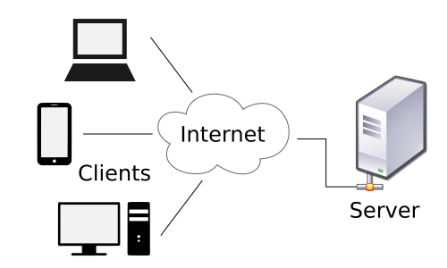

Client

The ParKing app is connected to a server computer over the Internet to obtain JSON data from an API. The diagram above shows the client-server architecture in a graphical drawing that shows which APIs are used by ParKing.

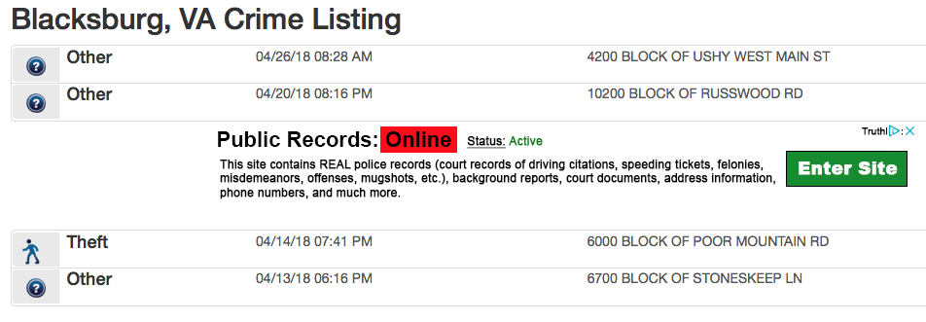

SpotCrime is a website that posts public police records of crimes in areas all across the country. This is where our app gets the API data for the Augmented Reality.

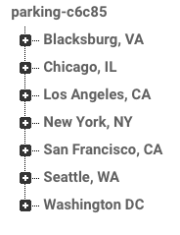

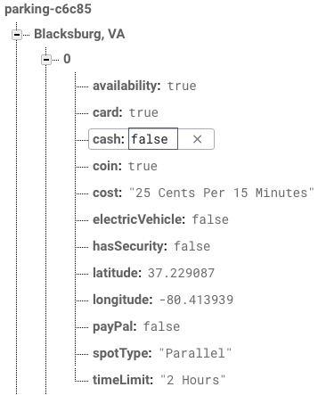

FireBase is a Google-owned database that stores and writes data for the parking spot locations and directions. When a user manually adds a parking spot, it is sent to FireBase and is added to the directory to be used by all others that use the app.

# DESIGN SPECIFICATION

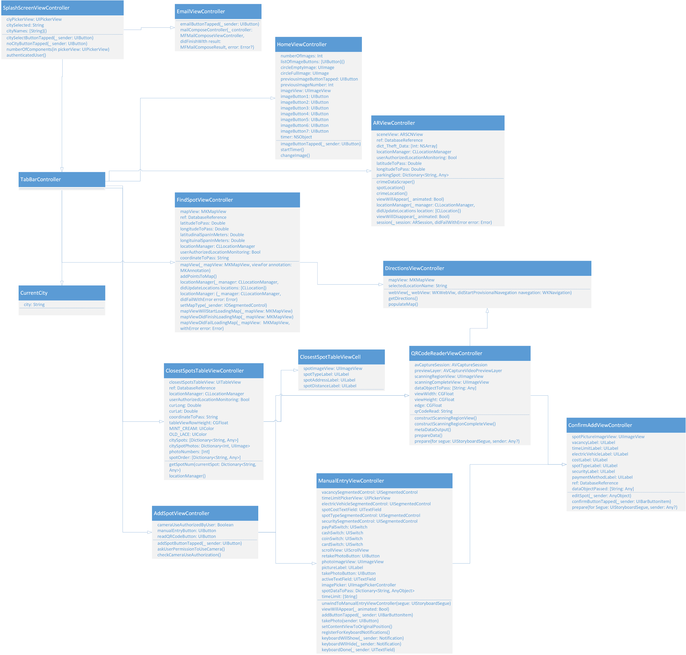

Below is a closer view of the UML:

* We realize that the diagrams may be a little hard to see, please pinch to zoom in this doc to see them in clearer detail *

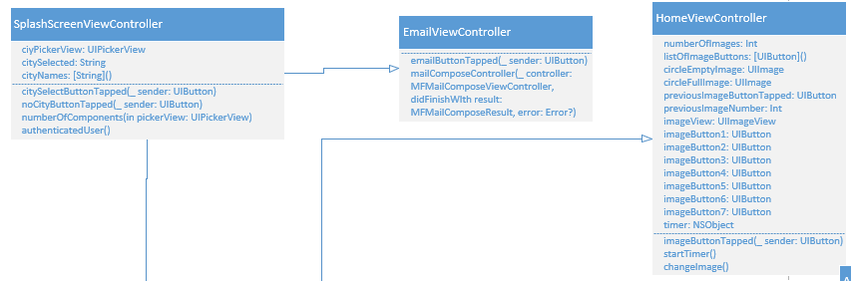

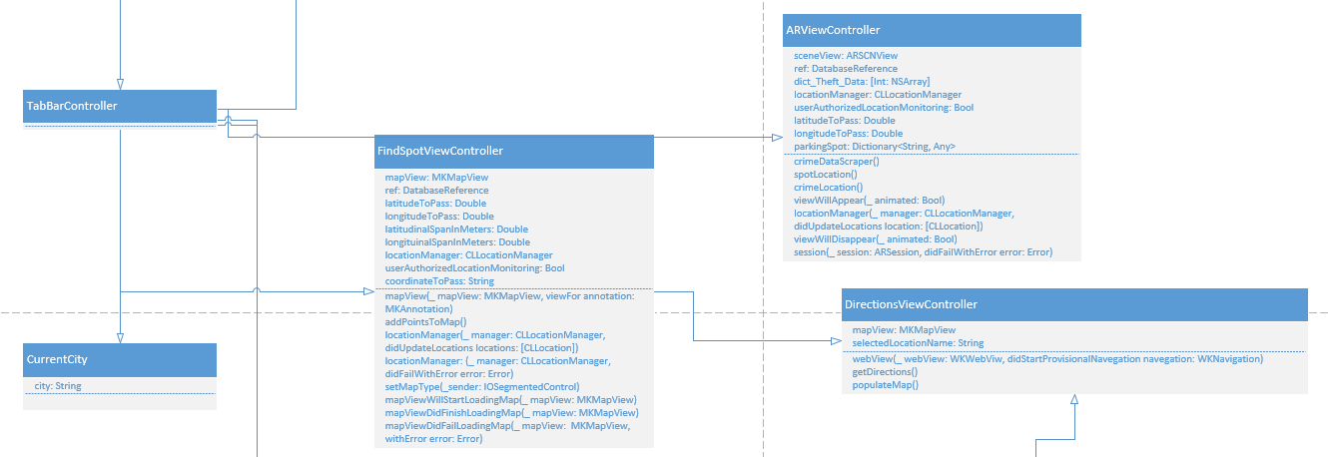

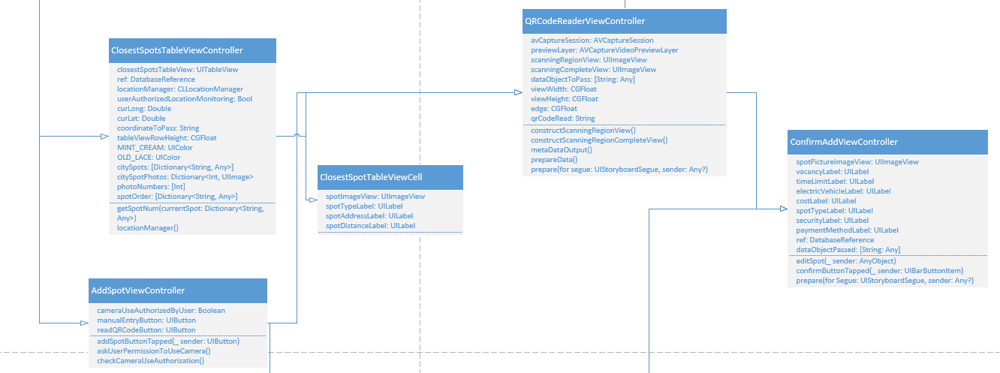

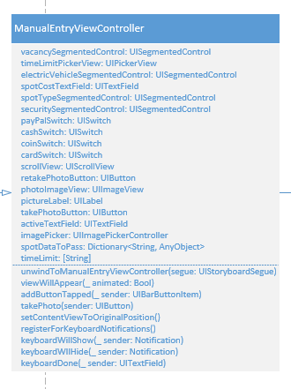

# DELIVERED SOFTWARE FUNCTIONALITY

1. **Launch Screen**

This is the Launch Screen Image that we created using Adobe Illustrator. We were able to create different sizes that followed this structure:

{

"images" : [

{

"idiom" : "iphone",

"filename" : "LaunchImage.png",

"scale" : "1x"

},

{

"idiom" : "iphone",

"filename" : "LaunchImage@2x.png",

"scale" : "2x"

},

{

"idiom" : "iphone",

"filename" : "LaunchImage@3x.png",

"scale" : "3x"

}

],

"info" : {

"version" : 1,

"author" : "xcode"

}

}

1. **Splash Screen**

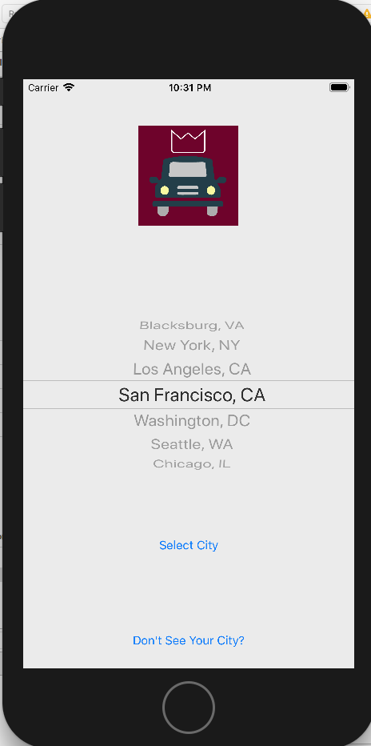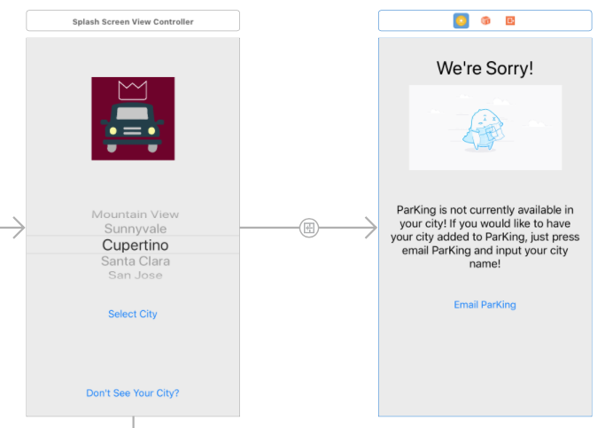

Upon first opening the app, you are met with this splash screen. This first asks if the app can use your location, as well as lets the user select the city they would like to use the app in. If you see your city, you simply use the UIPickerView and click the button “Select City”. If you do not see your city, you can click the button “Don’t See Your City?”. If you click the “Don’t See Your City?” button, it leads you to the screen on the right which lets you send an email through the app to contact your ParKing in order to request that parking information be available in your city.

1. **Email Through iOS Mail App**

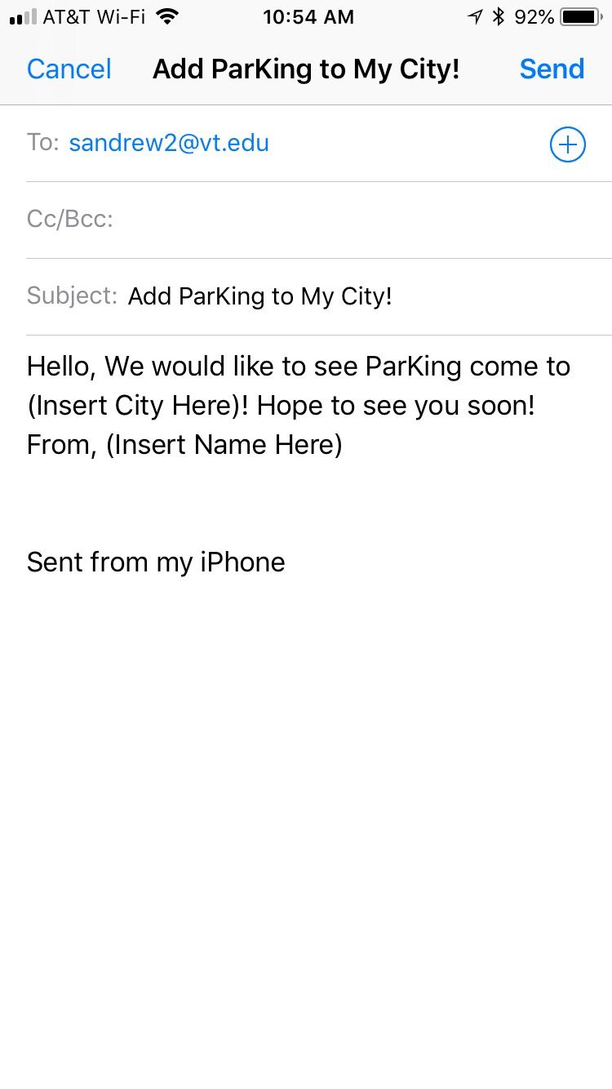

Clicking on the email ParKing button will then bring up iOS’s native email application. This will only work if an email account has been set up on the device and it is connected to the internet. If not, it sell say that the mail service is currently unavailable. If it does work it will bring up the above screen where it will ask for you to insert your city, and name and send the email to ParKing!

1. **Home Tab**

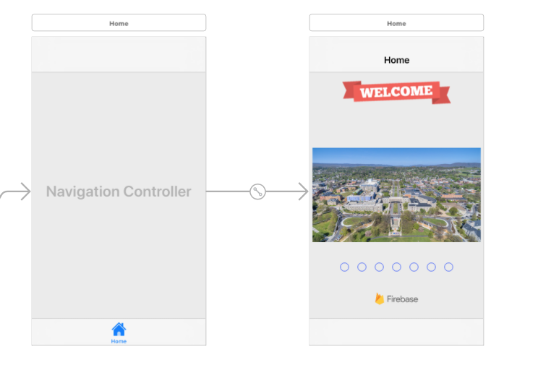

If you do find your city, and click the “Select City” button, you are brought to this home screen. Here the home screen images are images obtained from FireBase that are of the city that you selected. After a few seconds the images rotate to new ones of that city, which is reflected with the button indicators under the image. For example, if you previously selected Blacksburg, VA, the images would be of the town of Blacksburg as well as VT’s campus.

1. **Find Spot**

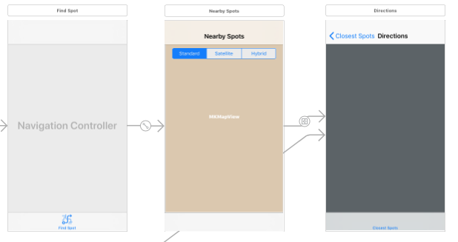

The next tab is the Find Spot tab, where the user goes to find nearby parking spots. We use Google’s Firebase to get parking location data and display nearby parking spots to the user through the MapView. The user can choose to view the map in standard, satellite, or hybrid mode. The user is shown their current location with a pin which is marked by saying “You Are here”. All nearby spots are noted by pins as well. The user can click on a desired parking space to see if it is available or not. If it is, the pin displays: “Available!”, and the user can click on the “+” in order to get directions to that spot. Once a user decides on a parking spot to select, they are directed to the Directions view where they are directed to the selected spot from their current location. The application uses Google Maps for the directions.

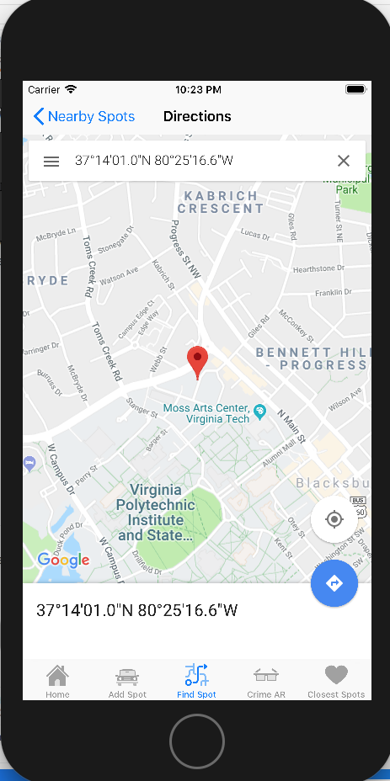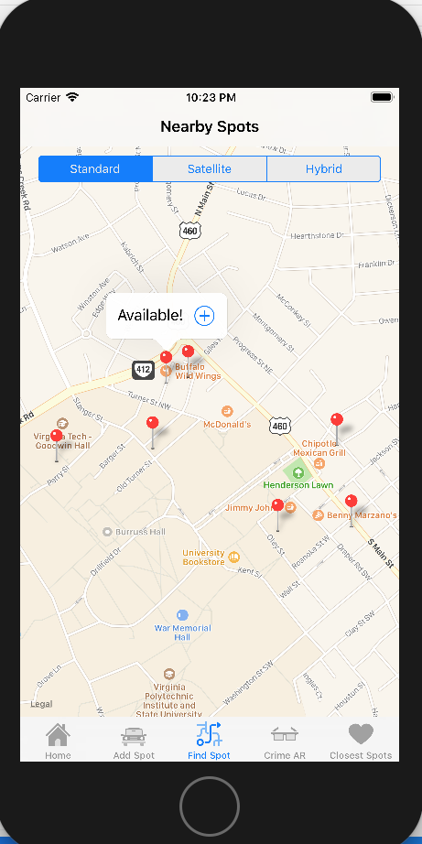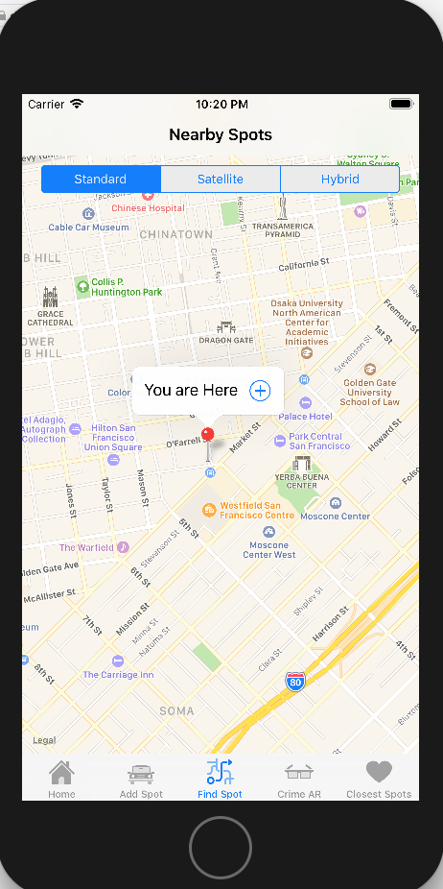

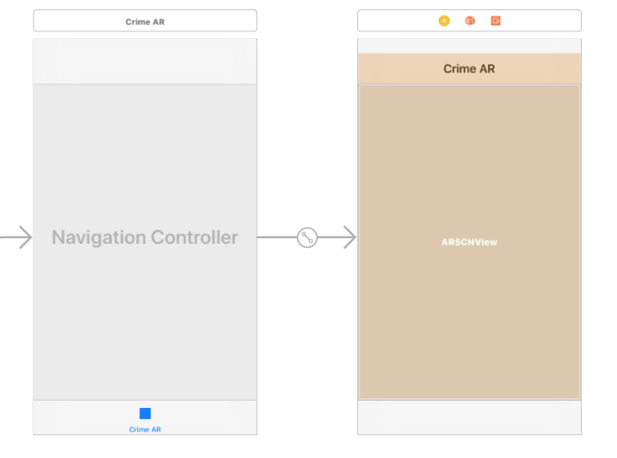

1. **Crime AR**

The next tab is the Crime / Augmented Reality tab. The user can click on this tab to open up the camera in a ARSCNView which automatically renders the live video feed from the device camera as the scene background. When the user is at a parking spot and opens up this tab, relevant local crime data (from the SpotCrime API) will be displayed on the screen in order to inform the user about where they are parking. An example of this is given in the diagram below.

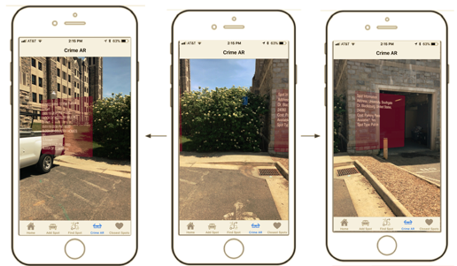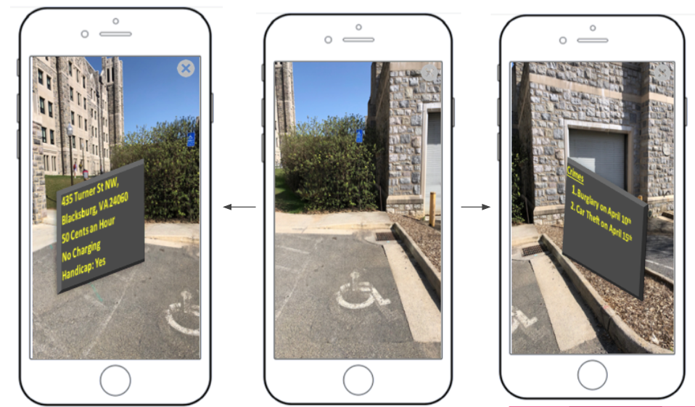

On the left, there is the address of the parking spot. On the right includes all recent crimes within a recent time period. Please see Crime AR tutorial for more details.

1. **Add Spot**

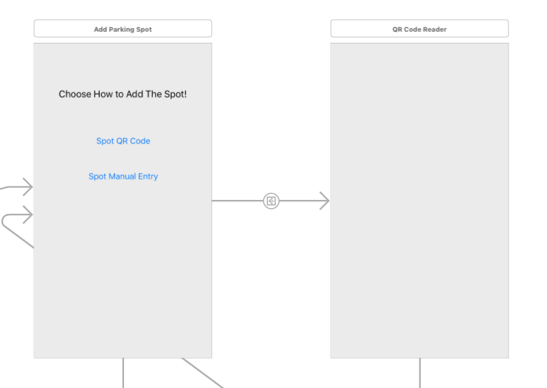

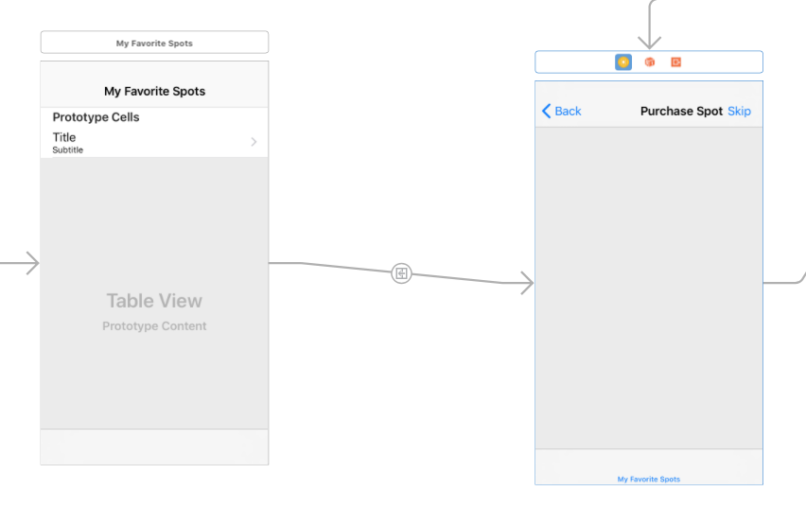The next tab is the Add Spot tab. This tab allows the user to add a parking spot to the Firebase database to be used by users in the future. The user can add a parking space in two ways. By clicking the “Spot QR Code” button, the user is first asked permission to use the camera, then brought to a QR Code reader in order to scan the QR code at the parking spot (usually at parking meters). Or, the user can click “Spot Manual Entry” which will bring you to the screen below

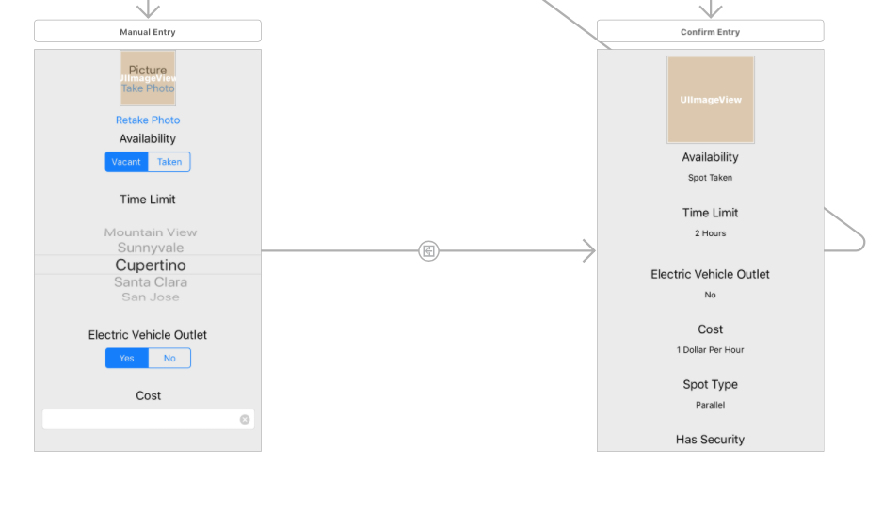

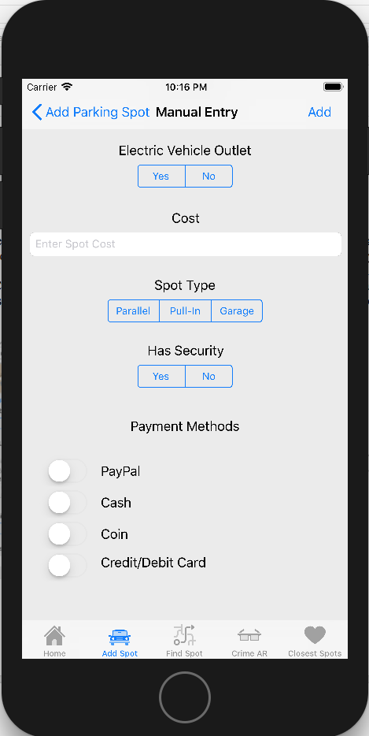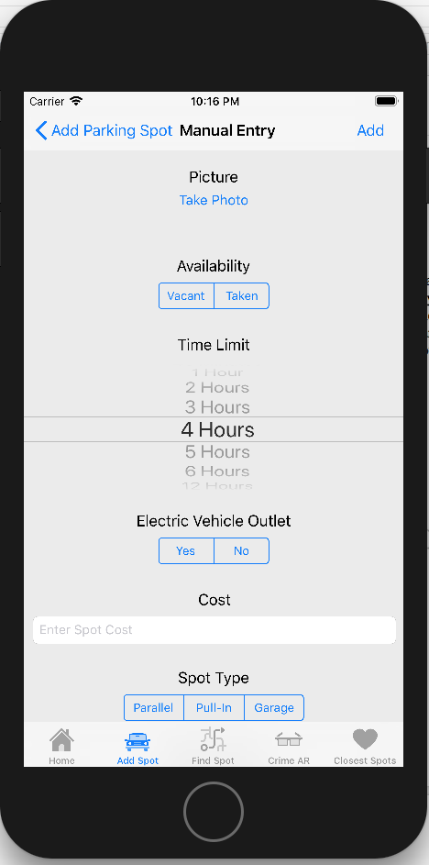

Here, the user can manually enter all the necessary data about the parking spot that they would like to add to the database. This includes availability, time limit, location (city), accessibility, cost, etc. Regardless of the way a spot is to be added, the user is then directed to a confirmation screen to make sure all of the inputted data is correct. Below are some additional photos showing the functionality of the Add Parking Spot tab.

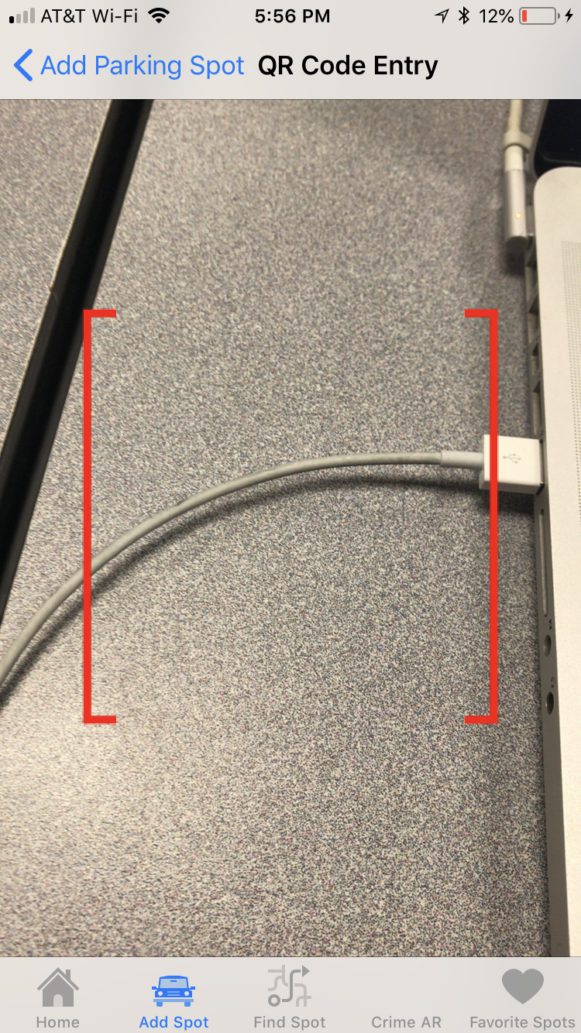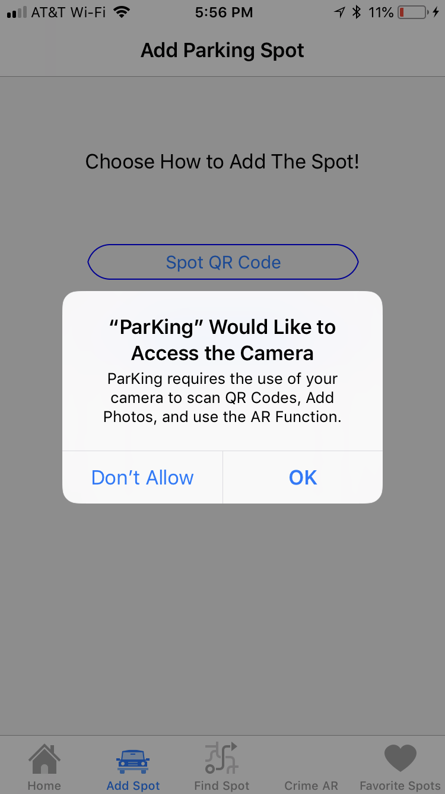

**Example QRCodes:**





These are example QR Codes that our team generated. They go off of a basic format that we could give out to cities/businesses who could then put them on the fronts of their garages, parking lots, or individual parking meters for cities and towns. Both of these example QR codes are for spots in Blacksburg.

1. **Closest Spots**

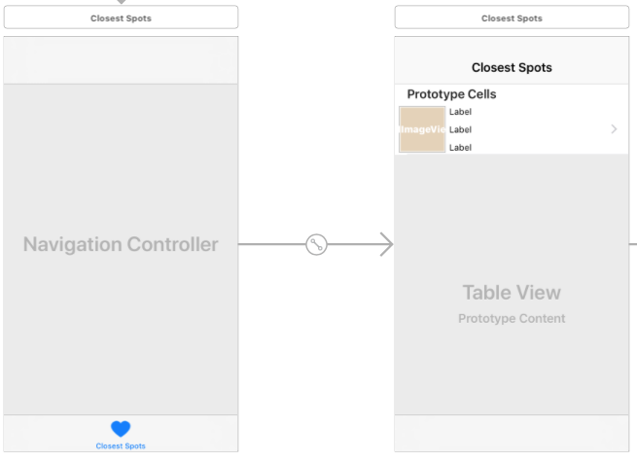

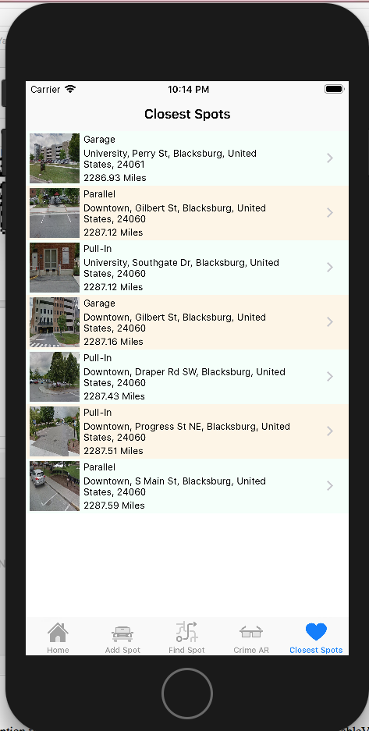

Another tabbed option that the user has is Closest Spots. Here, the app displays a UITableView where the closest parking spots are put in a list from closest to farthest. From here, the user can click on a parking spot and be directed to the Directions view, as mentioned in the map display of Nearby spots. This data is also pulled from Google’s Firebase.

# STEP-BY-STEP INSTRUCTIONS FOR DEVELOPING NEW FEATURES

* 1. **Augmented Reality ([ARKit](https://developer.apple.com/library/content/navigation/" \l "section=Technologies&topic=ARKit)) with [SceneKit](https://developer.apple.com/library/content/navigation/" \l "section=Technologies&topic=SceneKit)**

**Tutorial: CrimeAR**

**Learning Objectives**

1. How to create Sprite Kit Objects and Node Shapes with ARKit for Augmented Reality.

**Step 0: Earlier Phases of the Software Life Cycle**

We assume that earlier phases of the Software Life Cycle have been completed. See Dr. Balci's [Software Life Cycle](https://manta.cs.vt.edu/cs3714/StudentsOnly/Handouts/SELifeCycle.html). The life cycle processes Problem Formulation, Requirements Engineering, Architecting, and Design are assumed to be completed. In this tutorial, we focus on the Programming process.

**Step 1: Application Functionality Specification**

The CrimeAR app is designed to show you how to use ARKit to build augmented reality experiences. Specifically in this app, two panels will appear to the left and right of the camera view depicting the closest crimes in the area sorted by date as well as the parking location data of the specific area. You would need the users current location to pull in relevant data. We will be using the SpotCrime api (<https://spotcrime.com>) for pulling crimes in the area, and retrieving parking data from Firebase.

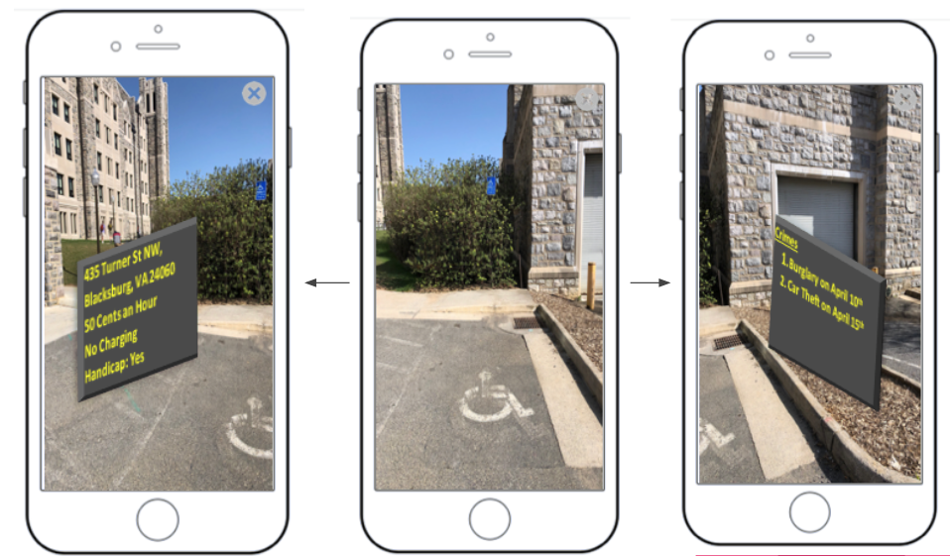Microsoft Word Mockup of Intended Results at a Parking Location on Campus

Actual Render of Intended Results at a Parking Location on Campus

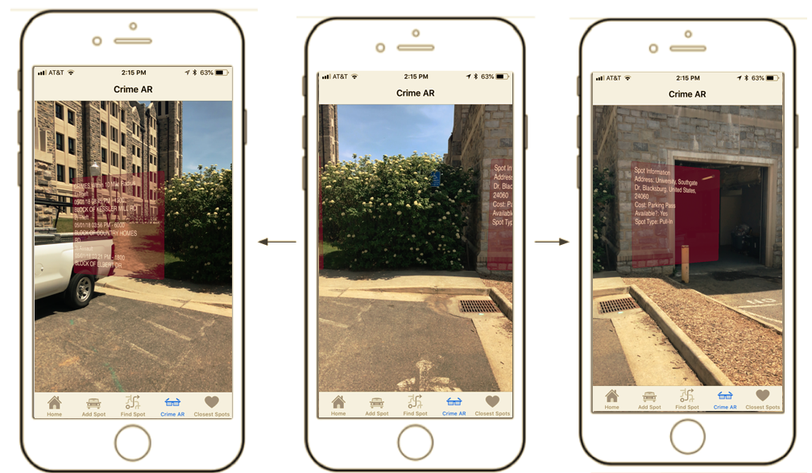

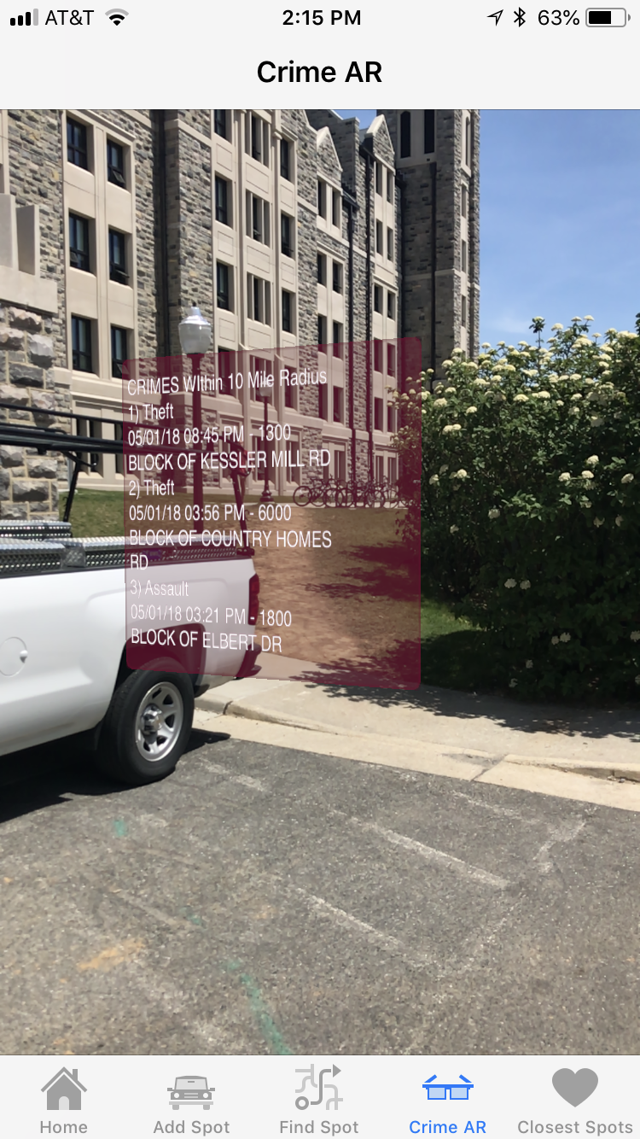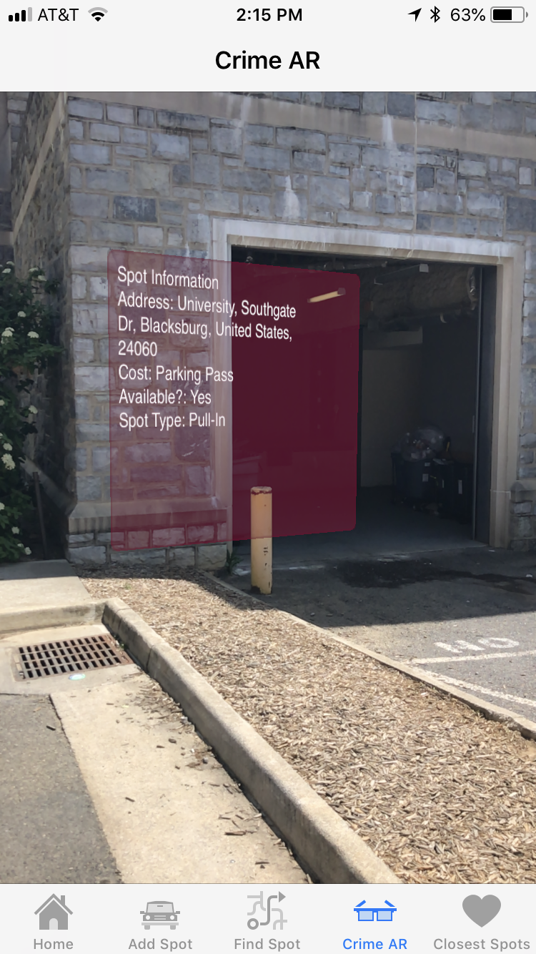Close Up Pics of AR SKShapeNode View

**Step 2: Creation of a New Project**

**Create New Project Folder**

1. Create your new project using the**Single View App**template.
2. Enter *Product Name* as**CrimeAR**
3. Enter *Organization Name* as **YourFirstName YourLastName**
4. Create the app to work on all **iPhone** devices.

Please see table below for compatible devices:

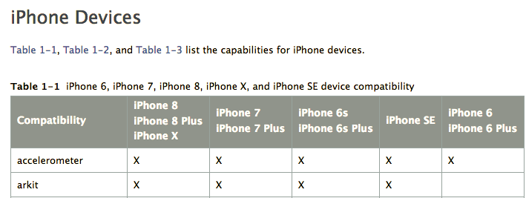

https://developer.apple.com/library/content/documentation/DeviceInformation/Reference/iOSDeviceCompatibility/DeviceCompatibilityMatrix/DeviceCompatibilityMatrix.html

**Assign the Images and Create the Launch Screen**

Assign all imported images and create the launch screen.

**Link Framework**

* CoreLocation.framework
* ARKit.framework

Scroll down to reveal **Linked Frameworks and Libraries** and expand it as shown in the following screenshot.

Click the + (Add) button under the **Linked Frameworks and Libraries** to add a framework as shown below.

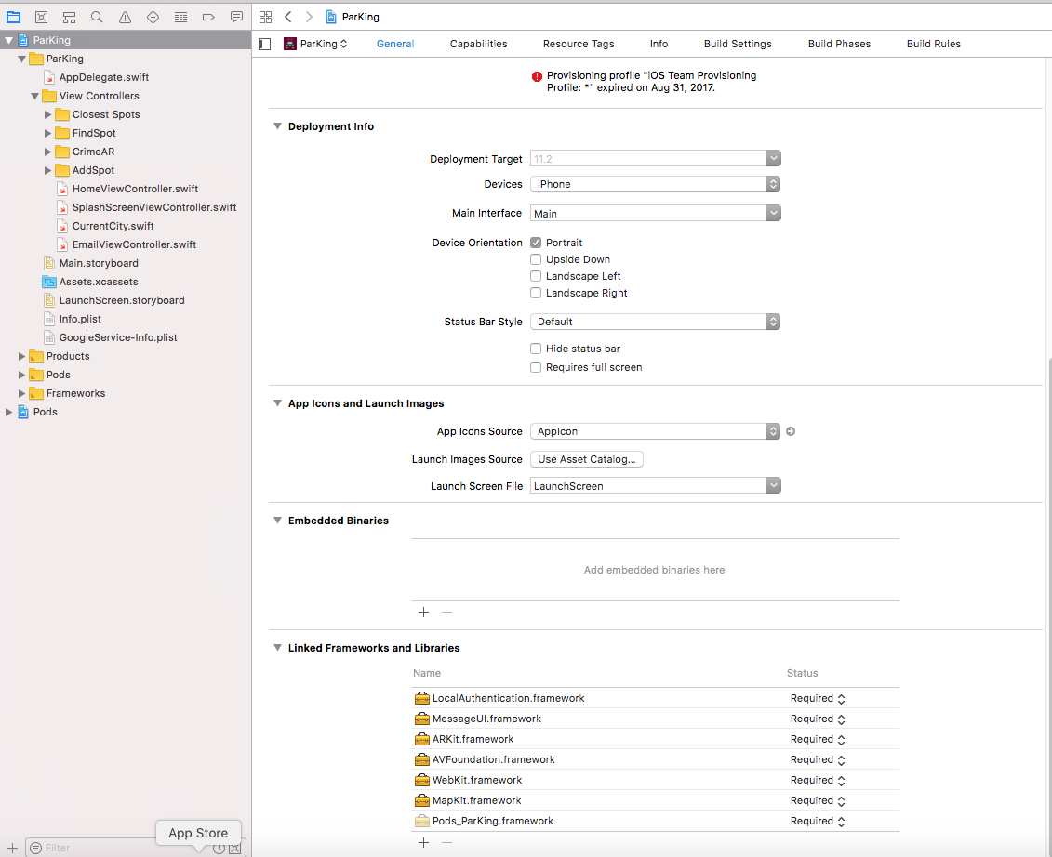

In the *Choose frameworks and libraries to add* dialog, scroll down and click **ARKit.framework** to select it and then click **Add** to add it to your project.

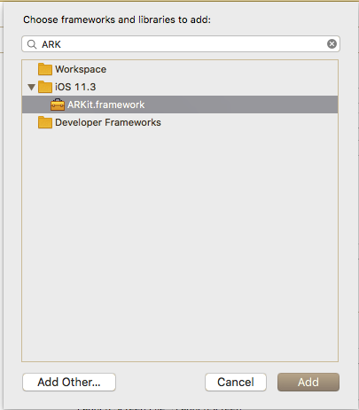

**Step 3: User Interface Development**

The augmented reality nodes will be created programmatically, so in this case, all you would need for user interface development is to add ARKit SceneKit View to your view controller.

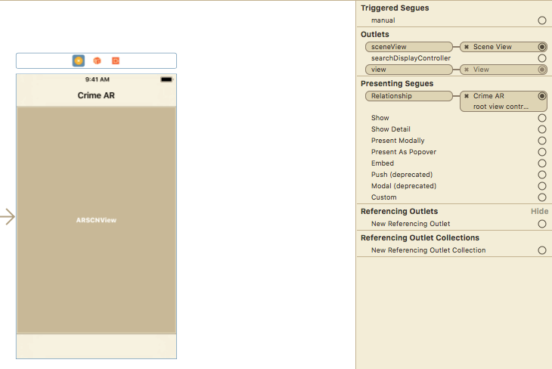

Make sure to add your constraints on this object as well.

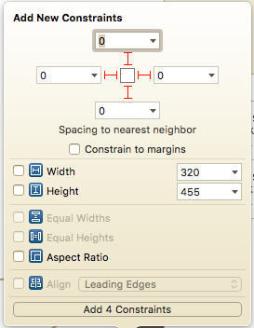

**Step 4: ARKit Class Development**

Now we are all set up on the Storyboard, so we can implement the class file.

Here are the imports that are needed:

import UIKit

import SceneKit

import ARKit

import FirebaseDatabase

import CoreLocation

class CrimeARViewController: UIViewController, ARSCNViewDelegate, CLLocationManagerDelegate {

// ARKit Scene

@IBOutlet var sceneView: ARSCNView!

In the ViewDidLoad function, make sure you also set the delegate

// Set the view's delegate

sceneView.delegate = self

I have included the function that will pull all the relevant data that is needed for augmented reality. I will not be explaining this as the comments within the code does a great job explaining how I got about this and we had done a lot of this in prior Tutorials. This tutorials main focus is to explain how to implement AR.

/*

* Makes the API Calls:

*

* You would need the users current location to pull in relevant data. We will be using the SpotCrime api

* (https://spotcrime.com) for pulling crimes in the area, and retrieving parking data from Firebase.

*/

func crimeDataScraper() {

// Spotcrime API URL

let apiUrl = "http://api.spotcrime.com/crimes.json?lat=\(self.latitudeToPass! as Double)&lon=\(self.longitudeToPass! as Double)&radius=10&key=heythisisforpublicspotcrime.comuse-forcommercial-or-research-use-call-877.410.1607-or-email-pyrrhus-at-spotcrime.com"

let url = URL(string: apiUrl)

let jsonData: Data?

do {

jsonData = try Data(contentsOf: url!, options: NSData.ReadingOptions.mappedIfSafe)

} catch {

return

}

if let jsonDataFromApiUrl = jsonData {

do {

let jsonDataDictionary = try JSONSerialization.jsonObject(with: jsonDataFromApiUrl, options: JSONSerialization.ReadingOptions.mutableContainers) as? NSDictionary

// Typecast the returned NSDictionary as Dictionary<String, AnyObject>

let dictionaryOfCountryJsonData = jsonDataDictionary! as! Dictionary<String, Any>

let crimeData = dictionaryOfCountryJsonData["crimes"] as! NSArray as! [Any]

var count = 0

for (item) in crimeData {

// set data as a Dictionary

let data = item as! NSDictionary

// prevalent data

let type = data["type"] as! String

let date = data["date"] as! String

let address = data["address"] as! String

let crimeData = [type, date, address]

// append all crimes within 10 miles to dict

dict_Theft_Data[count] = crimeData as NSArray

count+=1

}

} catch let error as NSError {

print (error)

return

}

}

// retrieves the Firebase Database Reference

ref = Database.database().reference()

// iterates through the parking spots within the current city

ref.child(currentCity.city).observeSingleEvent(of: .value, with: { (snapshot) in

let spots: [Any] = snapshot.value as! [Any] // gets the list of parking spots

var coordinates = [CLLocationCoordinate2D]() // will store all of the coordinates from the parking spots

let currentLocation = CLLocation(latitude: self.latitudeToPass! as Double, longitude: self.longitudeToPass! as Double) // sets the current location

// iterates through the list of spots

for spot in spots {

// sets each spot as a dict

let obj = spot as! Dictionary<String, Any>

// creates a CLLocationCoordinate2D object from the latitude and longitude of the spot

let centerLocation = CLLocationCoordinate2D(latitude: obj["latitude"] as! Double, longitude: obj["longitude"] as! Double)

//appends these coordinates to an array

coordinates.append(centerLocation)

}

// iterate through all of the coordinates, and order them based on how far they are from the

// users current location

let sortedCoordinates = coordinates.map({CLLocation(latitude: $0.latitude, longitude: $0.longitude)}).sorted(by: {

$0.distance(from: currentLocation) < $1.distance(from: currentLocation)

})

// again iterate through the list of spots

for spot in spots {

// sets each spot as a dict

let obj = spot as! Dictionary<String, Any>

// if the closest spot to the users location is equal to the iterated spot, set that as the parking

// spot to display

if (obj["longitude"] as! Double == sortedCoordinates[0].coordinate.longitude && obj["latitude"] as! Double == sortedCoordinates[0].coordinate.latitude) {

self.parkingSpot = obj

}

}

// Sets the AR View for Parking Location Data

self.spotLocation()

// Sets the AR View for Crime Data

self.crimeLocation()

}) { (error) in

print(error.localizedDescription)

}

}

The two functions below contain all the information needed to create this AR experience. The comments themselves do a great job with explain what is going on. Some things to elaborate on are the different types of building blocks to AR. The SKNode class is the fundamental building block of most SpriteKit content. I will detail the list of all of the nodes used below taken from Apples Developer Page:

**SKScene:** The root node for all Sprite Kit objects displayed in a view.

**SKShapeNode:** A node that renders a shape defined by a Core Graphics path.

The data (SkLabelNode) will be displayed on top of this, but this node itself is transparent.

**SKLabelNode:** A node that displays a text label.

This contains all the data as a String taken from either the Crime API or Firebase

**SCNPlane:** A rectangular, one-sided plane geometry of specified width and height.

This is what the text will be shown in front of

**SCNMaterial:** A set of shading attributes that define the appearance of a geometry's surface when rendered.

This is how the plane will be textured.

**SCNNode:** A structural element of a scene graph, representing a position and transform in a 3D coordinate space, to which you can attach geometry, lights, cameras, or other displayable content.

SCNNode will contain the plain (SCNPlane)

/*

* ARView for Spot Information

*/

func spotLocation() {

// The root node for all Sprite Kit objects displayed in a view

let skScene = SKScene(size: CGSize(width: 400, height: 300))

skScene.backgroundColor = UIColor.clear

// the panel that data will be written on top of

let rectangle = SKShapeNode(rect: CGRect(x: 0, y: 0, width: 400, height: 300), cornerRadius: 10)

rectangle.fillColor = colorLiteral(red: 0.807843148708344, green: 0.0274509806185961, blue: 0.333333343267441, alpha: 1.0)

rectangle.strokeColor = colorLiteral(red: 0.439215689897537, green: 0.0117647061124444, blue: 0.192156866192818, alpha: 1.0)

rectangle.lineWidth = 5

rectangle.alpha = 0.4

let geocoder = CLGeocoder()

// retrieve the current location

let centerLocation = CLLocation(latitude: parkingSpot!["latitude"] as! Double, longitude: parkingSpot!["longitude"] as! Double)

// Look up the location and pass it to the completion handler

geocoder.reverseGeocodeLocation(centerLocation, completionHandler: { (placemarks, error) in

if error == nil {

// reverse geocoding to retrieve the data to populate the address string

let pm = placemarks! as [CLPlacemark]

if pm.count > 0 {

let pm = placemarks![0]

var addressString : String = ""

if pm.subLocality != nil {

addressString = addressString + pm.subLocality! + ", "

}

if pm.thoroughfare != nil {

addressString = addressString + pm.thoroughfare! + ", "

}

if pm.locality != nil {

addressString = addressString + pm.locality! + ", "

}

if pm.country != nil {

addressString = addressString + pm.country! + ", "

}

if pm.postalCode != nil {

addressString = addressString + pm.postalCode! + " "

}

// Once the address is found, output the spot information

// to String temp

var spot_information = "Spot Information\n"

spot_information += "Address: " + addressString + "\n"

spot_information += "Cost: " + (self.parkingSpot!["cost"] as! String) + "\n"

spot_information += "Available?: " + (self.parkingSpot!["availability"] as! Bool ? "Yes" : "No" ) + "\n"

spot_information += "Spot Type: " + (self.parkingSpot!["spotType"] as! String) + "\n"

// A node that displays a text label

let labelNode = SKLabelNode()

labelNode.text = spot_information

labelNode.lineBreakMode = NSLineBreakMode.byWordWrapping

labelNode.numberOfLines = 10

labelNode.preferredMaxLayoutWidth = 300

labelNode.fontSize = 20

labelNode.fontName = "San Fransisco"

labelNode.position = CGPoint(x:150,y:120)

skScene.addChild(rectangle) // add the display panel to the scene

skScene.addChild(labelNode) // add the text label to the scene

// this makes the panel more visually appealing

let plane = SCNPlane(width: 20, height: 20)

// A set of shading attributes that define the appearance of a geometry's

// surface when rendered

let material = SCNMaterial()

material.isDoubleSided = true

material.diffuse.contents = skScene

material.diffuse.contentsTransform = SCNMatrix4Translate(SCNMatrix4MakeScale(1, -1, 1), 0, 1, 0)

plane.materials = [material]

// A structural element of a scene graph, representing a position and transform

// in a 3D coordinate space, to which you can attach geometry, lights, cameras, or other

// displayable content.

let node = SCNNode(geometry: plane)

node.position = SCNVector3(x: 25, y: 0, z: -50)

// add the node to the main view

self.sceneView.scene.rootNode.addChildNode(node)

}

}

})

}

/*

* ARView for Crime Information

*/

func crimeLocation() {

// The root node for all Sprite Kit objects displayed in a view

let skScene = SKScene(size: CGSize(width: 400, height: 300))

skScene.backgroundColor = UIColor.clear

// the panel that data will be written on top of

let rectangle = SKShapeNode(rect: CGRect(x: 0, y: 0, width: 400, height: 300), cornerRadius: 10)

rectangle.fillColor = colorLiteral(red: 0.807843148708344, green: 0.0274509806185961, blue: 0.333333343267441, alpha: 1.0)

rectangle.strokeColor = colorLiteral(red: 0.439215689897537, green: 0.0117647061124444, blue: 0.192156866192818, alpha: 1.0)

rectangle.lineWidth = 5

rectangle.alpha = 0.4

// Get the most recent crime data within a 10 mile radius from the users current location

var temp = "CRIMES WIthin 10 Mile Radius\n"

temp += "1) " + (dict_Theft_Data[0]![0] as! String) + "\n" + (dict_Theft_Data[0]![1] as! String) + " - " + (dict_Theft_Data[0]![2] as! String) + "\n"

temp += "2) " + (dict_Theft_Data[1]![0] as! String) + "\n" + (dict_Theft_Data[1]![1] as! String) + " - " + (dict_Theft_Data[1]![2] as! String) + "\n"

temp += "3) " + (dict_Theft_Data[2]![0] as! String) + "\n" + (dict_Theft_Data[2]![1] as! String) + " - " + (dict_Theft_Data[2]![2] as! String) + "\n"

// A node that displays a text label

let labelNode = SKLabelNode()

labelNode.text = temp

labelNode.lineBreakMode = NSLineBreakMode.byWordWrapping

labelNode.numberOfLines = 10

labelNode.preferredMaxLayoutWidth = 300

labelNode.fontSize = 20

labelNode.fontName = "San Fransisco"

labelNode.position = CGPoint(x:150,y:20)

skScene.addChild(rectangle) // add the display panel to the scene

skScene.addChild(labelNode) // add the text label to the scene

// this makes the panel more visually appealing

let plane = SCNPlane(width: 20, height: 20)

// A set of shading attributes that define the appearance of a geometry's

// surface when rendered

let material = SCNMaterial()

material.isDoubleSided = true

material.diffuse.contents = skScene

material.diffuse.contentsTransform = SCNMatrix4Translate(SCNMatrix4MakeScale(1, -1, 1), 0, 1, 0)

plane.materials = [material]

// A structural element of a scene graph, representing a position and transform

// in a 3D coordinate space, to which you can attach geometry, lights, cameras, or other

// displayable content.

let node = SCNNode(geometry: plane)

node.position = SCNVector3(x: -25, y: 0, z: -50)

// add the node to the main view

sceneView.scene.rootNode.addChildNode(node)

}

After adding these code bits, you should have a functioning AR experience! WOW!

## Touch ID Authentication Using LocalAuthentication Framework

This feature is used to lock one or more parts of your app behind a authentication protocol, in this case the TouchID function of iOS. Now to add this function to your app you must start by adding the LocalAuthentication.framework to your app.

1. First go to the AppName under the Project Navigator, in this case ParKing
2. Scroll down to reveal **Linked Frameworks and Libraries** and expand it as shown in the following screenshot.
3. Click the + (Add) button under the **Linked Frameworks and Libraries** to add a framework as shown below.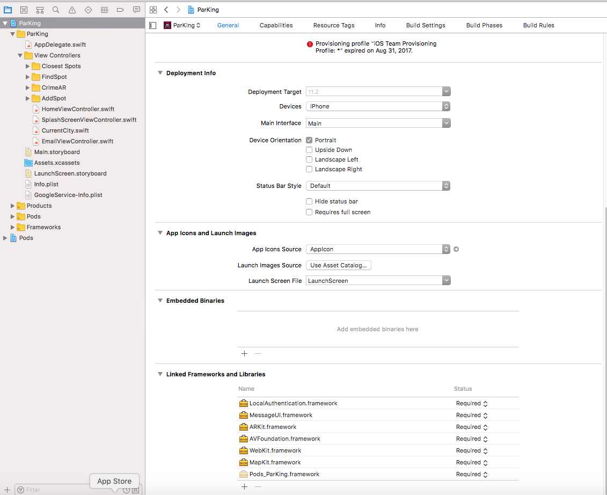
4. In the *Choose frameworks and libraries to add* dialog, scroll down and click **LocalAuthentication.framework** to select it and then click **Add** to add it to your project.

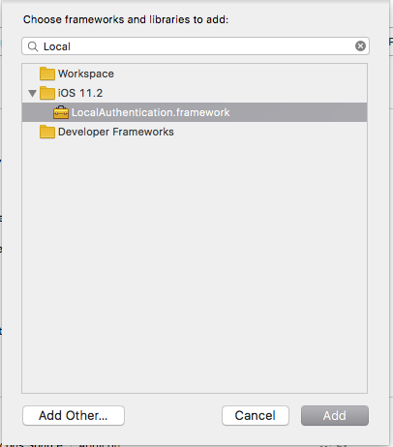

1. Next, we want to set up our view, now this will vary based on how you want to apply the authentication measure. In this case we will set up a simple button. That will activate the authentication check.
2. Going to the storyboard, take the view controller that you want to house the Authentication check.
3. Show the Utility area. Select **Object Library** from the Library Selector Bar.
4. Select the **View (Scene) object** in the document outline pane.
5. Drag a **Button** (UIButton) object from the Object Library and drop it on top of the selected View (Scene) object's canvas as shown in the following screenshot. 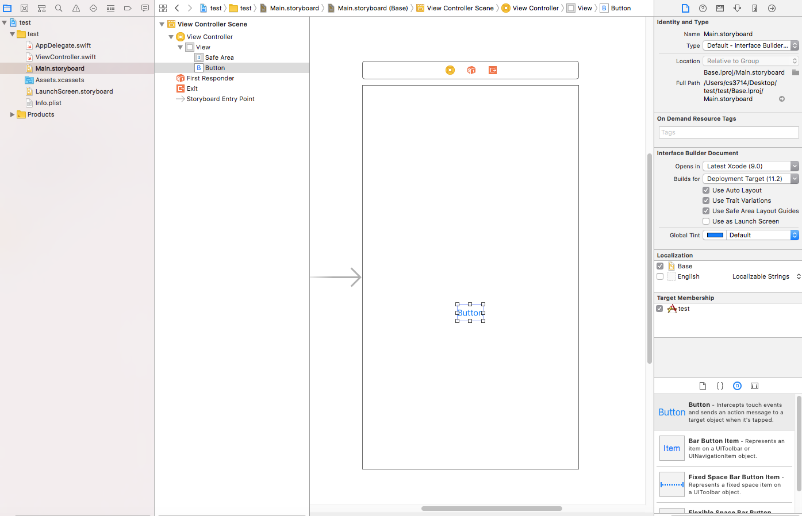
6. Apply auto-layout constraints as necessary.
7. Now we are all set up on the StoryBoard, we need to add the code.
8. Head into your view controller for the scene you set up.
9. First, we need to import the LocalAuthentication framework.
10. Then you will need authentication protocol shown in the code below: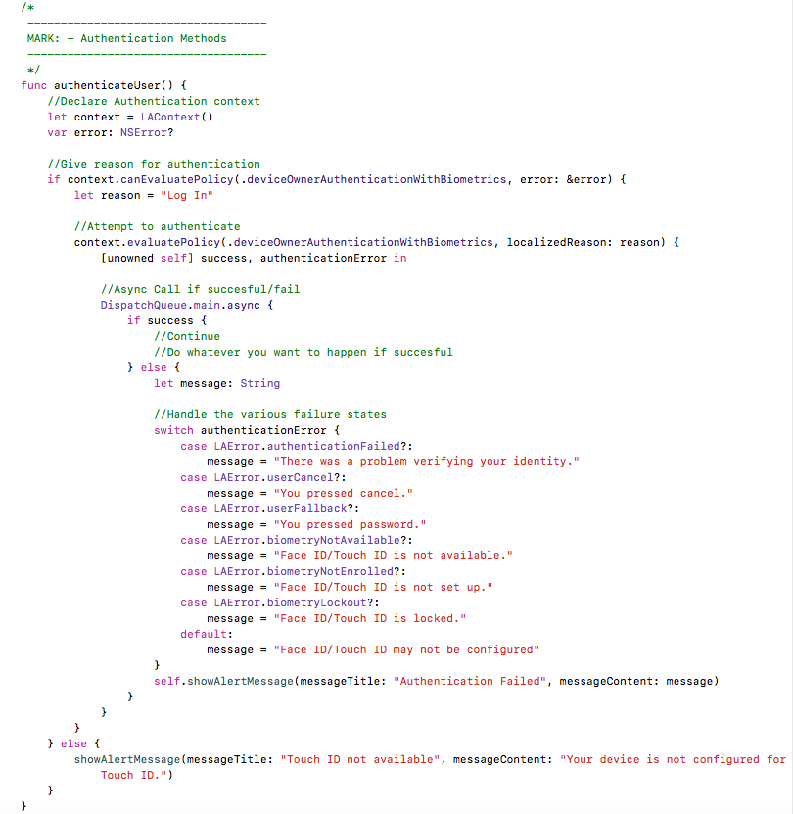
11. You will also need the helper function showAlertMessage() in order to display alerts to the user about the status of the authentication. Code shown below:

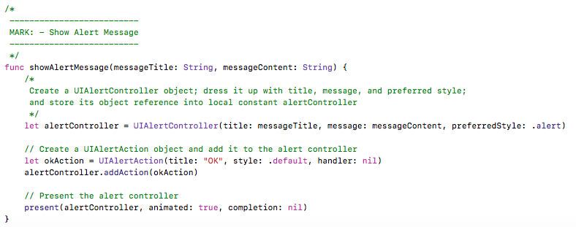

1. The final step is to call the authenticateUser() function when the button is pressed.
2. To do this, we will set up a simple IBAction method which will detect the button press and call the authentication function.

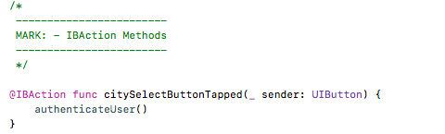

1. Now we must connect the button to the action method, so we head back the the storyboard. Clicking on the view, then going to the top right of the screen and click on the connections inspector. Towards the bottom, we need to connect the button the the action by dragging from the action to the button and selecting **Touch Up Inside** so it looks like this:

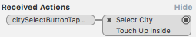

1. In this case my button is called **Select City**, yours is whatever you called your button.
2. Finally clicking on the button should show: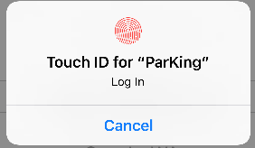

Where “ParKing” is the name of your app.

1. And you’re done!

## Send Email Message In The App

This feature allows you to send an email directly from the app to an address, with a message, and a subject line that you specify. However, the user can modify these after the mail app opens. In order for this feature to work the user must have an email account linked to their iPhone.

1. First go to the AppName under the Project Navigator, in this case ParKing
2. Scroll down to reveal **Linked Frameworks and Libraries** and expand it as shown in the following screenshot.
3. Click the + (Add) button under the **Linked Frameworks and Libraries** to add a framework as shown below.
4. In the *Choose frameworks and libraries to add* dialog, scroll down and click **MessageUI.framework** to select it and then click **Add** to add it to your project.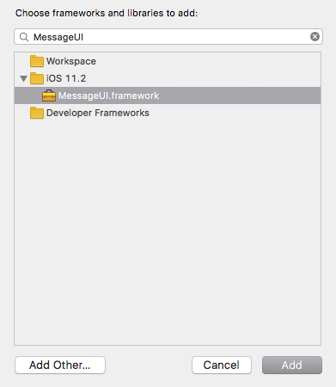
5. Next, we want to set up our view, now this will vary based on how you want to send the email. In this case we will set up a simple button. That will activate the email send.
6. Going to the storyboard, take the view controller that you want to house the Authentication check.
7. Show the Utility area. Select **Object Library** from the Library Selector Bar.
8. Select the **View (Scene) object** in the document outline pane.
9. Drag a **Button** (UIButton) object from the Object Library and drop it on top of the selected View (Scene) object's canvas as shown in the following screenshot. 
10. Apply auto-layout constraints as necessary.
11. Now we are all set up on the StoryBoard, we need to add the code.
12. Head into your view controller for the scene you set up.
13. First, we need to import the MessageUI framework, and add the MFComposeViewControllerDelegate to the class as shown below: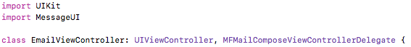
14. Now we are ready for the actual email methods: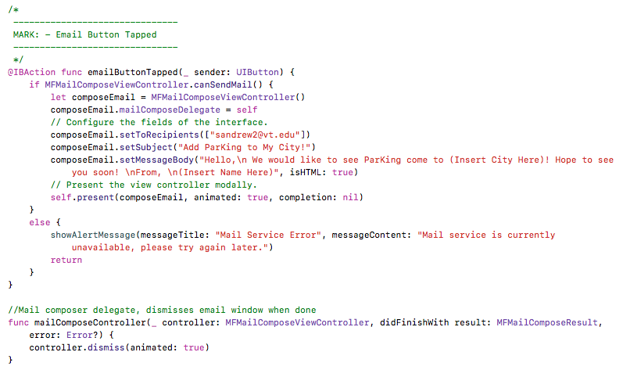
15. The first method setups up the actual method, showing body, recipient, and message body, while the second is used to dismiss the view when done.
16. You will also need the helper function showAlertMessage() in order to display alerts to the user about the status of the mail service. Code shown below:



1. Now we must connect the button to the action method, so we head back the the storyboard. Clicking on the view, then going to the top right of the screen and click on the connections inspector. Towards the bottom, we need to connect the button the the action by dragging from the action to the button and selecting **Touch Up Inside** so it looks like this:

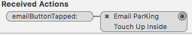

1. In this case my button is called **Email ParKing**, yours is whatever you called your button.
2. Finally clicking on the button should show:



1. However if the mail server is unavailable, or no mail account is linked to the iPhone, you will get:

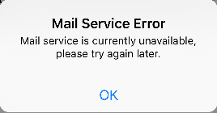

1. And you’re done!

## Store and Retrieve Data and Photos using Firebase Database and Storage

This feature allows for you to upload data like dictionaries to Firebase, as well as uploading other types of files such as photos to FirebaseStorage. FirebaseStorage is associated with your Firebase database project so they link nicely!

1. Before we begin, Firebase has a number of requirements for iOS:
   1. Xcode 8.0 or later
   2. An Xcode project targeting iOS 8 or above
   3. Swift projects must use Swift 3.0 or later
   4. The bundle identifier of your app
   5. CocoaPods 1.2.0 or later
2. As long as all those requirements are met, you are ready to begin!
3. This tutorial will assume that you already have a project database setup in the Firebase console, and will focus solely on integrating said database and storage into your iOS project.
4. First, you must create the pod for your project.

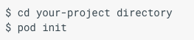

1. Add the pods to your project, for storage and database.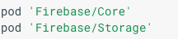
2. Install the pods, and open your project: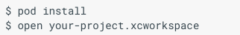
3. Now open your app delegate, and import the Firebase framework: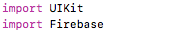
4. Then, configure Firebase in the application function of app delegate: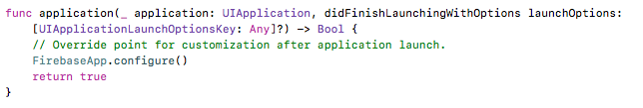
5. Now we are ready to start reading and writing data!
6. We will start by learning how to write a dictionary of data to Firebase!
7. This is all done in code, so go into your view controller and import the Firebase framework:

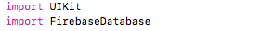

1. Now you are ready to do the actual write: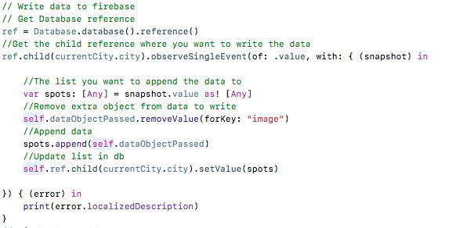
2. And that’s all you need to do to write data to your database!
3. Now to read for your database, you still need to import the Firebase framework like in step 11.
4. Then you need to add the function: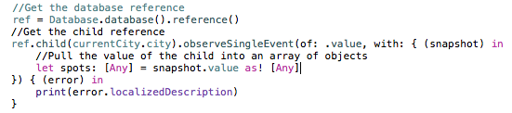
5. You can that do whatever you need with the data!
6. Now onto file storage, in our case photos.
7. We will again begin with writing a photo to the storage unit, and to do that we must import Firebase Storage framework:

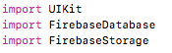

1. Importing FirebaseDatabase is NOT necessary for storage usage of files.
2. Then to add files: 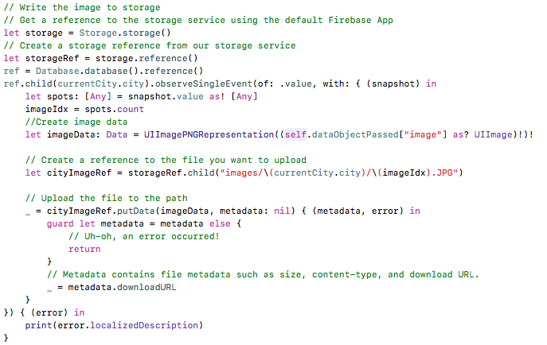
3. Now that we can add files, we may also want to pull them back down from storage. To do this we still need the FirebaseStorage import from step 18. And the code: 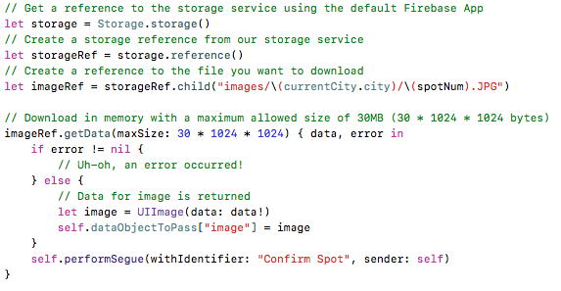
4. Using the above code allows you to pull down a given image as long as you know it’s path in your storage unit.
5. And you’re done! You can now read and write data and images to Firebase!

# CONCLUSIONS

In conclusion, the team learned a lot of things when developing the app ParKing. Firstly, it is essential that solution-providers utilize the Software Life Cycle when needed. Using the cycle made it systematically easier to develop the applications. We were able to successfully propose a problem and make our app specifications first, before working on any software components for the app which made the entire process a lot smoother. Getting feedback and testing the app during development was essential to the process. The team was constantly going back to that software life cycle in order to improve the application as problems arose during development. During one of the meetings, the team determined that one of the features (grabbing the metadata from photos taken within the application) was not possible, which threw a wrench into that new-feature that was being implemented. Developers need to stay “on their toes” and expect problems like these to arise in order to make timely adjustments to their projects in order to satisfy their customers.

Another takeaway from this project is that when coordinating with a team, app development can take way longer than expected, especially when incorporating new features that a potential client requests to have in their application. The team collaborated and worked on the semester for over 24 hours, and that was just the time spent in the same room together. Individually, the combined workload was over 72 hours which needed to be carefully planned out in order to get the job done.

Overall, the project was incredibly successful and the team is pleased with the end result. We were able to take the base idea of developing an app that assists with parking cars (a huge problem that affects millions of people around the globe) and create an easy-to-use solution.

# SUBMISSION INSTRUCTIONS

Please carefully follow the instructions below in submitting your project:

1. Place this project report file Team N Semester Project Report.docx and Xcode project folder in a folder named TeamN-iOSProject and compress it, where N is your team number.
2. Unzip the compressed file on another computer and make sure that the zip file is properly created. Only zip files are accepted.
3. Upload your zip file to your account in [Google Drive](https://www.google.com/drive/), right click the uploaded file and select **Share** from the pop-up menu, enter [balci@vt.edu](mailto:balci@vt.edu), add a note as CS3714 Team N Project Submission, and click Send before 8:00 a.m. on May 4 Friday**.** **Late submissions are not allowed.**
4. If your project iOS app is a multi-user app or an app that requires demonstration to evaluate its functionality, then get an appointment with Dr. Balci **before the due date** and go to his office to give a hands-on demo so that your app can be graded properly.

# PERCENTAGES OF CONTRIBUTION

We hereby certify that the list of contributions and the corresponding percentages of contribution specified below truly reflect the actual contributions of the team members.

(Write your name as your signature)

|  |  |  |
| --- | --- | --- |
| *Student Name & List of Contributions* | *% Contributed* | *Signature* |
| Andrew Shivers’ Contributions:   1. Add Spot Tab 2. Manual Add Scene 3. QR Code Add Scene 4. Spot Confirmation Scene 5. Firebase Add Spot Support 6. Firebase Storage Add Photo Support 7. Firebase Storage Pull Photo Support 8. Authentication Using TouchID | 36% | Andrew Shivers |
| Kavin Aravind’s Contributions:   1. Firebase Pod Setup 2. Crime AR View 3. SpotCrime API Pulls 4. Firebase Pull Spot Support 5. Created App Icons 6. Created Launch Screen Image 7. Find Spot Scene 8. MapKit Button Press Annotations 9. Google API Directions for Spots | 36% | Kavin Aravind |
| Tyler Urban’s Contributions:   1. Email ParKing in App 2. Closest Spot Scene 3. Closest Spot Cell 4. Home Screen Scene 5. UML Diagram | 28% | Tyler Urban |
| Sum of Percentages: | 100% |  |

# CALCULATION OF GRADES BASED ON PERCENTAGES OF CONTRIBUTION

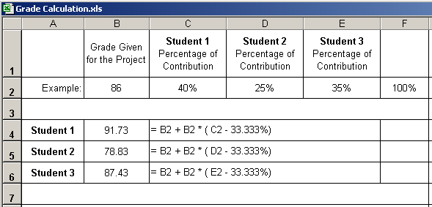

**Additional percentage of contribution cannot exceed 10%.**

**If a situation arises where a student is doing more than 10% extra work, Dr. Balci must be informed immediately.**

# TEAM PROJECT REQUIREMENTS

1. Each team member is expected to contribute equally.
2. You shall submit percentages of contribution together with a list of each student’s individual contributions with signatures of all team members. In case of disagreement, you shall submit it separately with your rationale. (Write your name as representing your signature.)
3. Grades shall be determined based on the percentages of contribution.
4. If you contribute more than your equal share, then your grade shall be increased based on the extra percentage of contribution, which cannot be more than 10%.
5. If you contribute less than your equal share, then your grade shall be decreased accordingly.
6. The extra percentage of contribution shall not be more than 10%. Dr. Balci shall be notified immediately if a situation arises where a student needs to contribute more than 10% extra.
7. A team member who does not cooperate with other team members for conducting the project with equal contribution shall be penalized. Doing more work than agreed upon by the team and claiming extra contribution shall not be acceptable. Cooperation is essential!

# GRADING SHEET

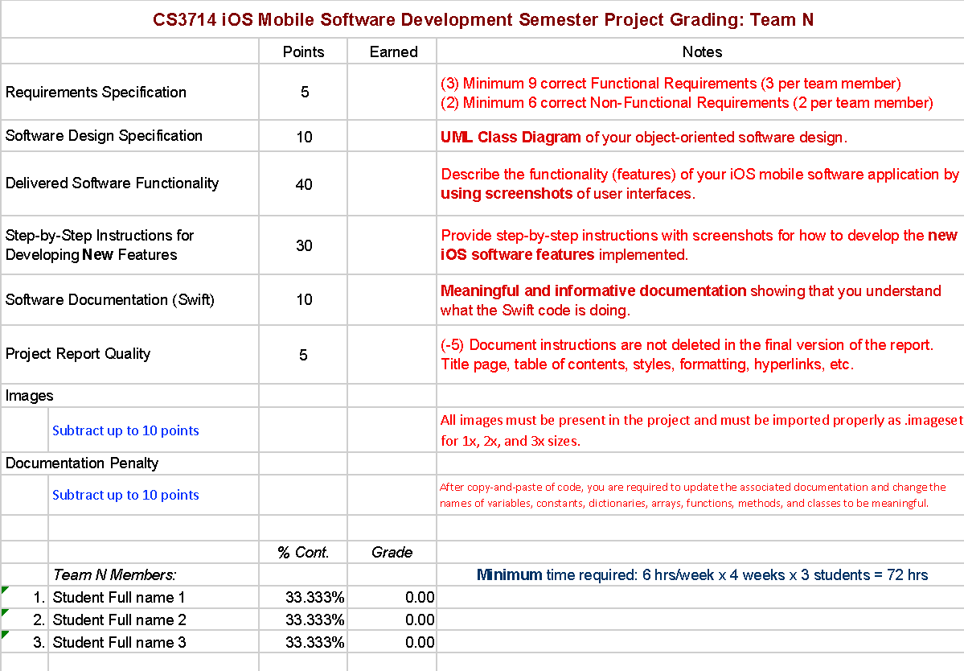

**REFERENCES**

Apple, Inc. (2017), “iOS Developer Library,” <https://developer.apple.com/library/ios/navigation/index.html>

Balci, O. (2016), “CS3714 iOS Mobile Software Development Course Website,” <https://manta.cs.vt.edu/cs3714>

Clover, J. (2017), “78% of Teens Surveyed Own an iPhone, 82% Plan to Purchase,”

https://www.macrumors.com/2017/10/11/teen-iphone-survey-fall-2017/

Kedmey, D. (2014), “See Which Parts of the Country Have the Most iPhone Users,”

http://time.com/3425995/iphone-map/

Liesman, S. (2017), “America loves its Apple. Poll finds that the average household owns more than two Apple products,” <https://www.cnbc.com/2017/10/09/the-average-american->household-owns-more-than-two-apple-products.html

McCoy, K. (2017), “Drivers spend an average of 17 hours a year searching for parking spots,”

https://www.usatoday.com/story/money/2017/07/12/parking-pain-causes-financial-and-personal-strain/467637001/

(2018), “Add Firebase to your iOS Project”

https://firebase.google.com/docs/ios/setup

**APPENDIX A: MEETING MINUTES**

**Meeting Number 1**

|  |  |
| --- | --- |
| *Date & Duration:* | April 3rd, 2018 - 3 Hours |
| *Location:* | Torg 1080 |
| *Members Present:* | All Members |
| *Members Absent:* | None |
| *Discussions:* | Progress Presentation, App Logo Design |
| *Decisions Made:* | App Logo was designed |
| *Work Assignments:* | Kavin finished the App Logo design, Andrew started to draw out the app template design, Tyler began work on the presentation ppt |
| *Minutes Prepared By:* | Andrew Shivers |

**Meeting Number 2**

|  |  |
| --- | --- |
| *Date & Duration:* | April 4th, 2018 - 2 Hours |
| *Location:* | Torg 1080 |
| *Members Present:* | All Members-Andrew was late |
| *Members Absent:* | None |
| *Discussions:* | Progress Presentation |
| *Decisions Made:* | Finalized Progress Presentation |
| *Work Assignments:* | Andrew was to work on app design template, Tyler finished polishing the presentation, Kavin generated the app icons |
| *Minutes Prepared By:* | Tyler Urban |

**Meeting Number 3**

|  |  |
| --- | --- |
| *Date & Duration:* | April 9th, 2018 - 3 Hours |
| *Location:* | Torg 1080 |
| *Members Present:* | All Members |
| *Members Absent:* | None |
| *Discussions:* | Begin the slides for progress report 2, creating a github repo, starting UI design in Xcode |
| *Decisions Made:* | Began finalizing exact UI design |
| *Work Assignments:* | Tyler and Kavin are to work on the UML diagram, Andrew is to finish the UI design in Xcode |
| *Minutes Prepared By:* | Andrew Shivers |

**Meeting Number 4**

|  |  |
| --- | --- |
| *Date & Duration:* | April 11, 2018 - 1 Hour |
| *Location:* | Torg 1080 |
| *Members Present:* | All Members |
| *Members Absent:* | N/A |
| *Discussions:* | Functional/Non-Functional Requirements |
| *Decisions Made:* | We decided on the set of requirements |
| *Work Assignments:* | None |
| *Minutes Prepared By:* | Andrew Shivers |

**Meeting Number 5**

|  |  |
| --- | --- |
| *Date & Duration:* | April 16, 2018 - 4 Hours |
| *Location:* | Torg 1010 |
| *Members Present:* | All Members |
| *Members Absent:* | N/A |
| *Discussions:* | What features we want to work on for the presentation Thursday |
| *Decisions Made:* | The functionality to start on |
| *Work Assignments:* | Andrew Working on Spot Adds, Kavin AR Kit Research, Tyler works on Closest Spots |
| *Minutes Prepared By:* | Andrew Shivers |

**Meeting Number 6**

|  |  |
| --- | --- |
| *Date & Duration:* | April 28, 2018 - 8.5 Hours |
| *Location:* | Torg 1010 |
| *Members Present:* | Kavin, Andrew |
| *Members Absent:* | Tyler - OCS |
| *Discussions:* | Finalizing the App, working on persisting issues |
| *Decisions Made:* | Cut pulling geolocation from pic taken in app, not possible |
| *Work Assignments:* | Finish respective sections |
| *Minutes Prepared By:* | Andrew Shivers |

**Meeting Number 7**

|  |  |
| --- | --- |
| *Date & Duration:* | April 30, 2018 - 3 Hours |
| *Location:* | Torg 1010 |
| *Members Present:* | All Members |
| *Members Absent:* | None |
| *Discussions:* | Finalizing the App, working on report |
| *Decisions Made:* | Finish respective tutorials for new features, Tyler finished UML |
| *Work Assignments:* | See above |
| *Minutes Prepared By:* | Andrew Shivers |